CS555/455 Fall 2020

Programming Assignment 1
(Due on September 18, 2020 by 11:59pm)

I. Questions (20%):
(1) (as 2.11) (4%) Consider the two image subsets, S1 and S2, shown in the following figure. For V = {1}, determine whether these two subsets are (a) 4-adjacent, (b) 8-adjacent, or (c) m-adjacent.

S1 S2
0 0 0 0 0 0 0 1 1 0
1 0 0 1 0 0 1 0 0 1
1 0 0 1 0 1 1 0 0 0
0 0 1 1 1 0 0 0 0 0
0 0 1 1 1 0 0 1 1 1

(2) (as 2.15) (4%) Consider the image segment shown
(a) Let V= {0,1} and compute the lengths of the shortest 4-, 8-, and m-path between
p and q. If a particular path does not exist between these two points, explain
why.
(b) Repeat for V = {1,2}.

3 1 2 1 (q)
2 2 0 2
1 2 1 1
(p) 1 0 1 2

(3) Based on the definition of EXTADD(f, g),

(a) (2%) Design a block diagram to realize the EXTADD(f, g) operation using ADD and EXTEND operations.
(b) (2%) Compute the EXTADD(f, g), where f = 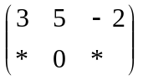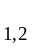 ; g = 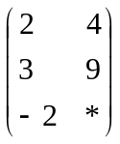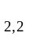

(4) 4%

Given the following histogram (A), after a shifting by T, the histogram becomes (B).
Write a transformation function and plot the transformation curve for such a shifting transformation.
0 1 2 3 4 5 6
A
T
B
(5) 4%

Give the histogram (A), after applying the transformation (C), plot the new histogram after the transformation.
0 1 2 3 4 5 6 255
A
C
0
255
255 input
output

(II) Programming Design (80%)

(1) Image grey-scale transformation (10%) and enhancement (15%) and write-up (5%)

- (7%) Given the following image, apply a grey-scale transformation function to create its negative image. Write your grey-scale transformation function and plot the corresponding transformation curve. Show the corresponding negative image.
- (3%) Print out the histogram of the original image and the histogram of its negative image.
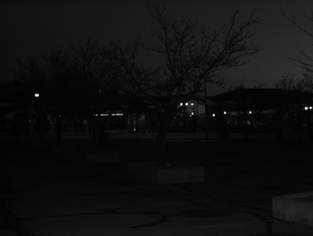
Figure 1: Test Image 1

- (8%) Histogram equalization is one of the effective approaches to enhance the image quality. This assignment is to implement the histogram equalization algorithm to process the above image for better visual quality. It is required to print out the images and the corresponding histograms before and after the histogram equalization.
- (7%) Apply the above procedure (3) to another test image (as shown below):

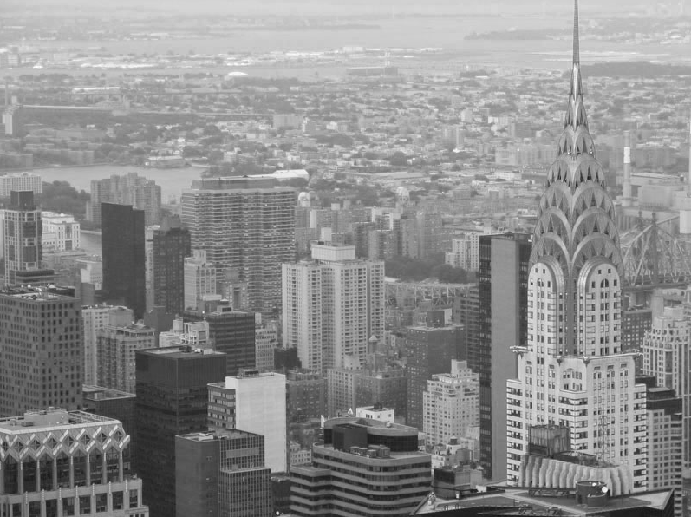
Figure 2: Test Image 2

(2) Region detection: finding the largest region, medium region, and the smallest region of the given image (45%) + write-up (5%)

- Description: Given the following image showing a number of shapes, detect and label the shapes automatically.

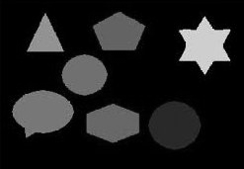
Figure 3: Test Image 3

Rank the detected regions from largest to smallest based on the number of pixels in each region. Your program should count the connected components of the detected regions. Connected component is to describe the basic relationship among the neighbor pixels in an image. Pixels that are connected can be labeled as a same region. In this assignment you are to implement this algorithm incorporating with the Histogram Calculation and image Thresholding Operations. Given a gray scale image, after converting this image into binary image by using thresholding algorithm, the binary image can be labeled on several connected component regions. The resulted image will show the separate regions detected.

Your implementation:

- (5%) Determine the optimal threshold T for further thresholding based on the image histogram.
- (6%) Apply T to converting the original image into binary image f1.
- (12%) Apply the 4-connected component algorithm to detect the regions of each shape.
Rank the sizes of detected shapes based on the count of their number of pixels. Label the letter with the largest region as RED (or gray level 200); the letter with medium size as GREEN (or grey level 120); the letter with the smallest size as BLUE (or grey level 60), obtain the labeled image f2.
- Print out your images f1and f2.
- Print out the threshold value T.
- (22%) Apply the above procedure (1)-(5) to the following test image as well.

Figure 4: Test Image 4

(3) Show the segments of text paragraph (Extra Points 15%)

Design an efficient algorithm to process the following document (Figure 5) for segmenting the paragraphs as shown in Figure 6.

(Hint: vertical integration and horizontal integration could be applied)

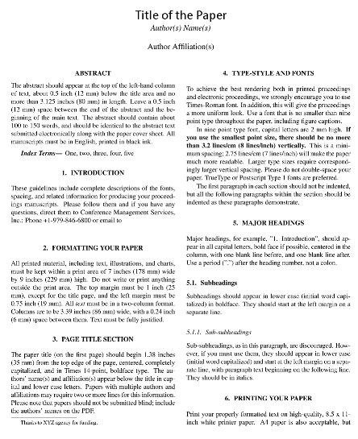
Figure 5: “template_paper_LowRes.bmp”
Figure 6: Example results of segmented sections

II. Hand-in

- Code package: Your program package includes all the files that can be re-compiled, executed, and demoed.
- Write-up: Report the experimental results along with figures and your description of the algorithms you designed and implemented, so that the reader can understand the method you used. Note: in the report, you should include following sections:
- Author’s Name and Email.
- Purpose of the project
- Method
- Results
- Bug report (if any), which includes “PARTS THAT ARE NOT COMPLETE” indicating any uncompleted parts of the project and any BUGS in your program that you are aware but have no idea why they exist.
- Submit your code and report (in a .ZIP file) through blackboard on/before the due date.

III. Hint

If you are running your program in VC++ environment, in order to avoid the over-stack problem in VC++ programming, you can set the stack as follows:

In the VC++ environment:

Project → Setting → Link →

Category→Output→Stack allocations→ Reserve → type “2000000”

